Creating an FISD blog (2010-11)
Go here: https://wiki.friscoisd.org/users/
Click here:
Login with your usual FISD login.
Click here: | 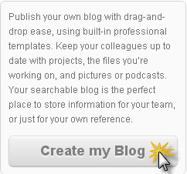
You are now ready to start blogging. | Your blog address will be:  www.wiki.friscoisd.org/users/(yourusername)

Getting to your blog:
Your Students, Parents, and yourself can get to your blog by going to your blog address. www.wiki.friscoisd.org/users/(yourusername) | Example: www.wiki.friscoisd.org/users/ashbyd
You can login with the button at the bottom of your blog: | 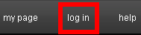

Configure the settings of your blog:
Once you are logged in you can click “Settings” under “Admin Functions in the right hand side bar. | 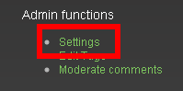
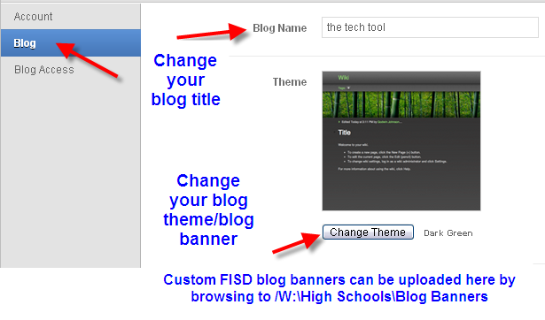
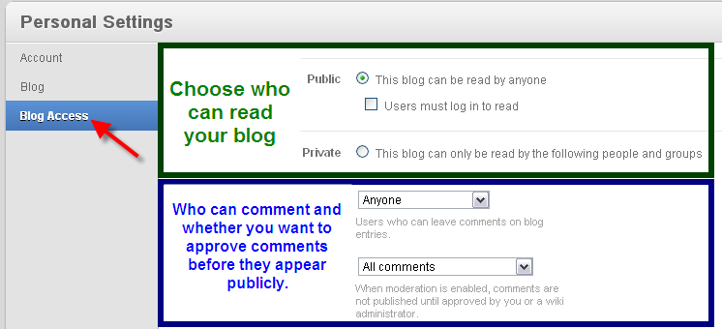

Using an FISD blog (2010-11)
Adding a new blog post:
Click on the + in the upper right hand corner | 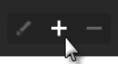
Give the post a title and click “Create” | 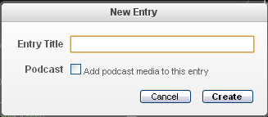
Change font size: | 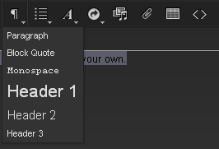
Add bullet points/numbers & Indent/outdent | 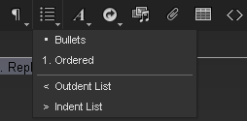
Format your text | 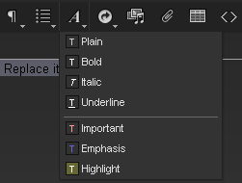
Create links to other webpages, blogposts, videos, etc… | 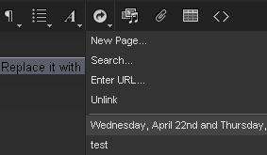
Add Add photos, videos, or audio | 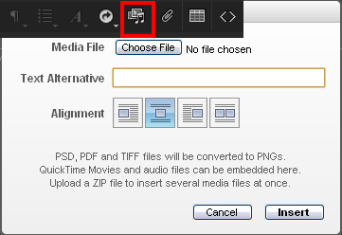
Insert a table/calendar | 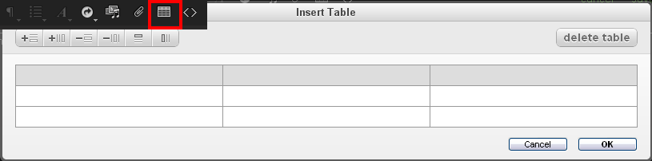
Important! You must click save when you are through and ready to publish your post

Editing/deleting existing blog posts:
To edit/delete any blog post you must first click on the title of the blog post. In this picture the titles are underlined in red. | 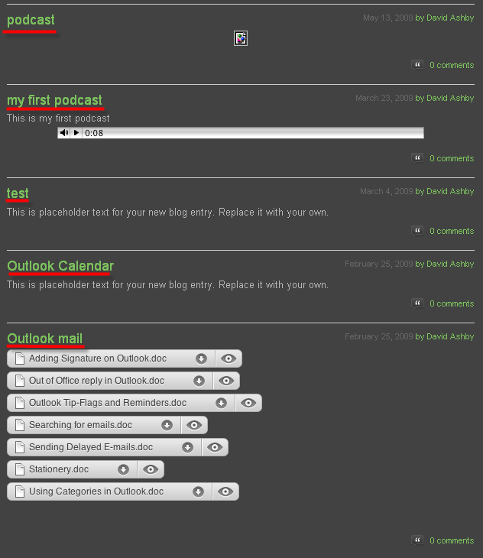
Once you have clicked on the post title you will see these three symbols in the upper right hand corner. | 